Assignment-11.1
Name: A.Nithin
Enroll ID:2403A54077
Batch: 03 (DS)
Task 1: Implementing a Stack (LIFO)
• Task: Use AI to help implement a Stack class in Python with the
following operations: push(), pop(), peek(), and is_empty().
• Instructions:
o Ask AI to generate code skeleton with docstrings.
o Test stack operations using sample data.
o Request AI to suggest optimizations or alternative
implementations (e.g., using collections.deque).
• Expected Output:
o A working Stack class with proper methods, Google-style
docstrings, and inline comments for tricky parts.
Code:
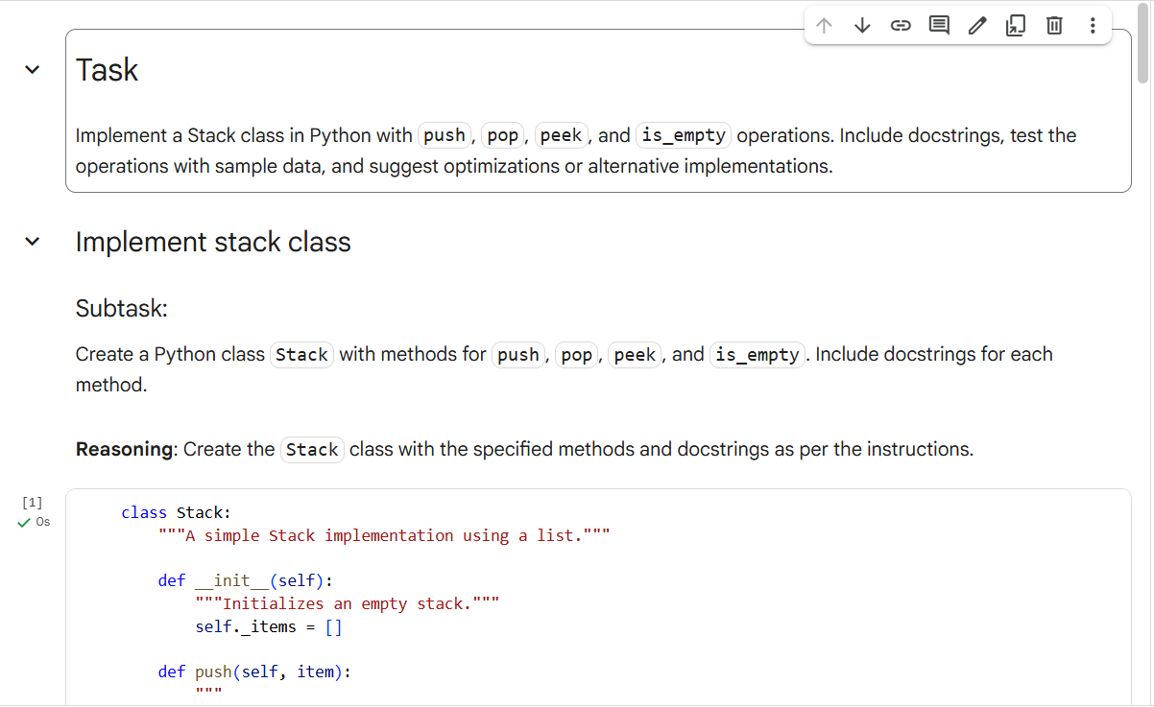
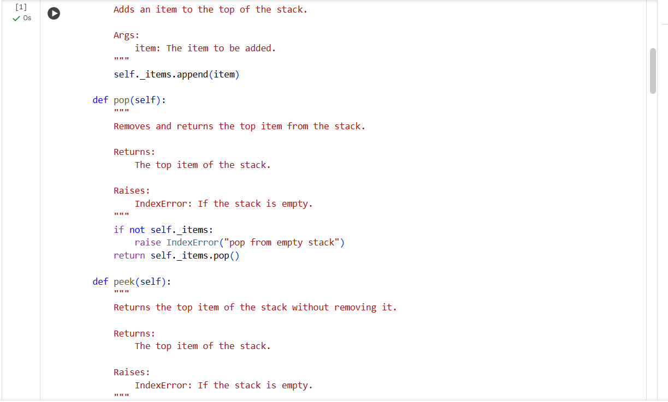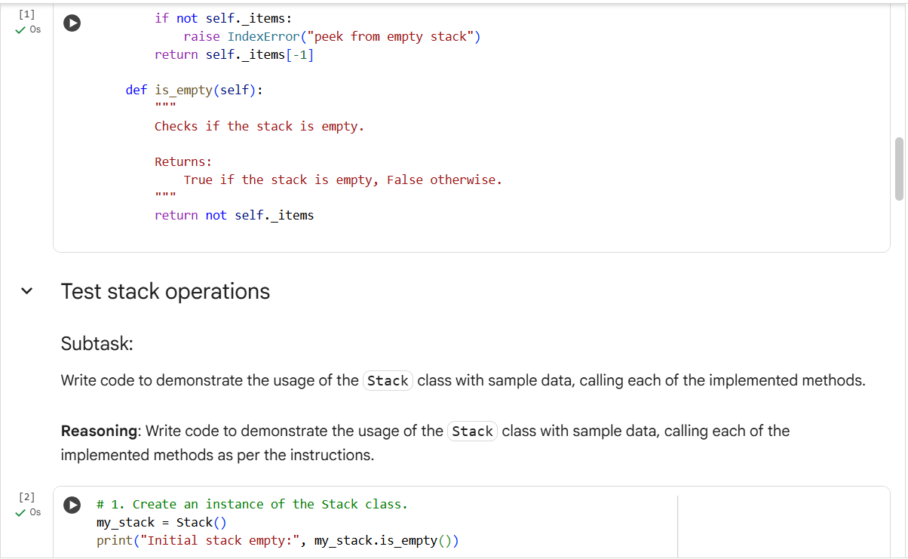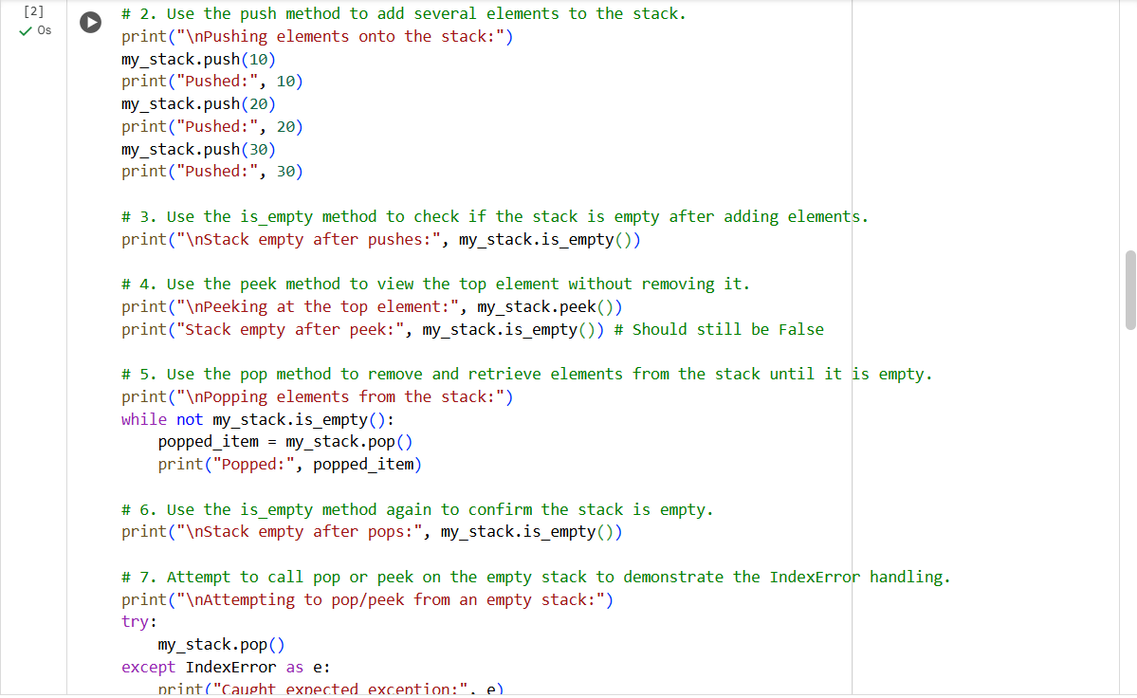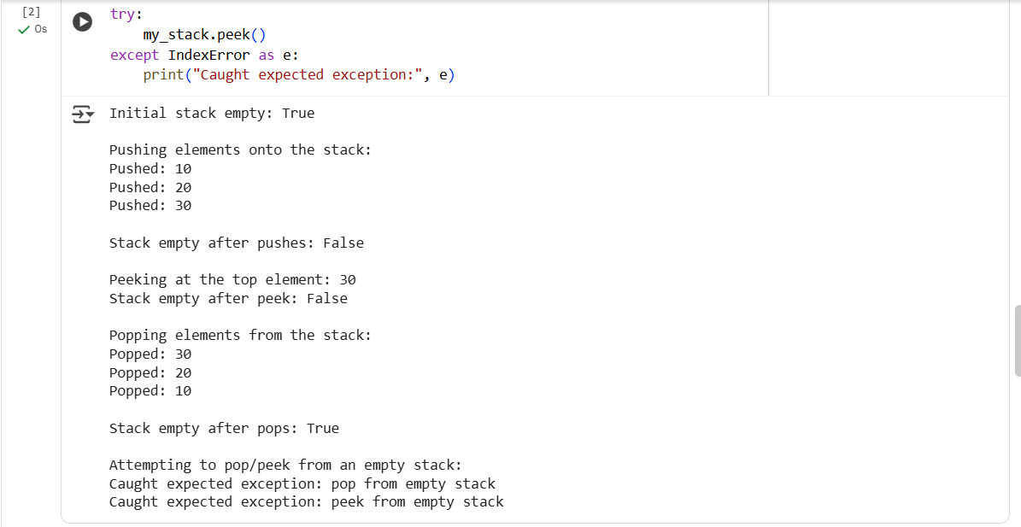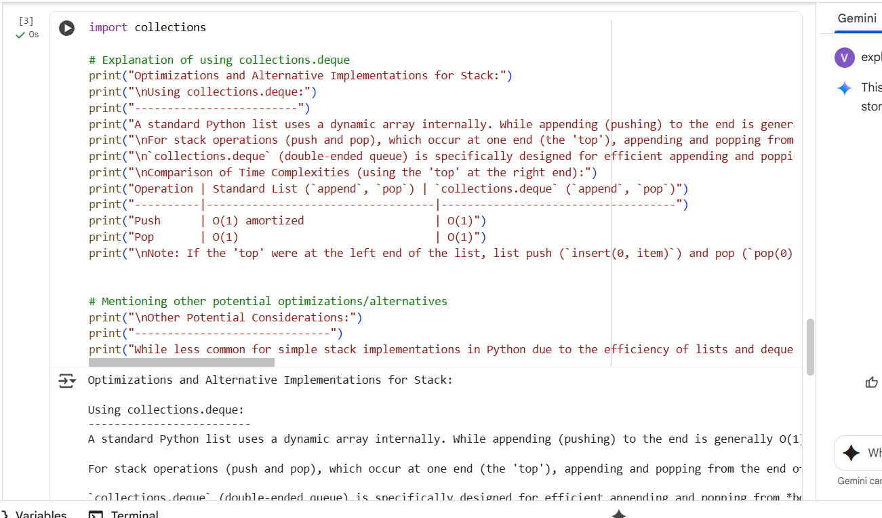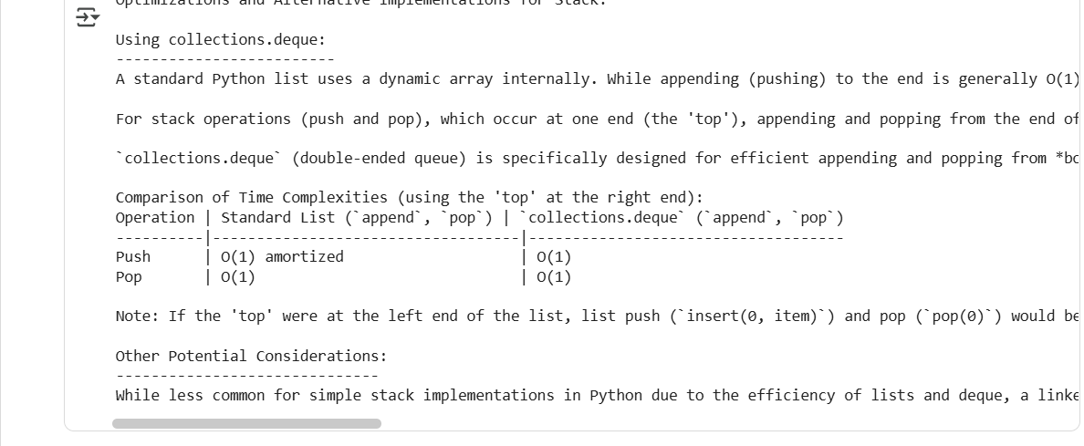

Explanation:
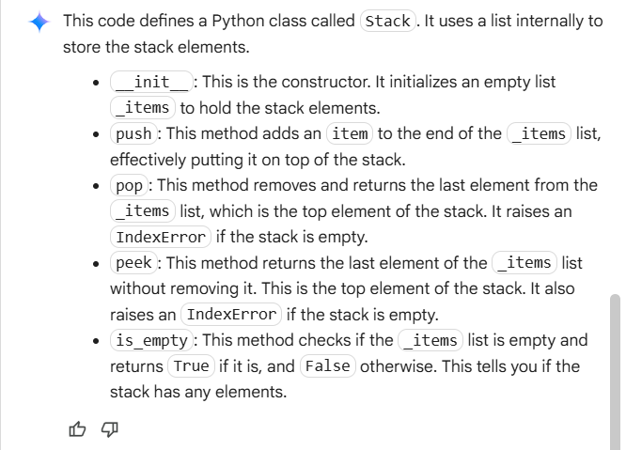

Task 2: Queue Implementation with Performance Review
• Task: Implement a Queue with enqueue(), dequeue(), and is_empty()
methods.
• Instructions:
o First, implement using Python lists.
o Then, ask AI to review performance and suggest a more
efficient implementation (using collections.deque).
• Expected Output:
o Two versions of a queue: one with lists and one optimized with
deque, plus an AI-generated performance comparison.
Code:
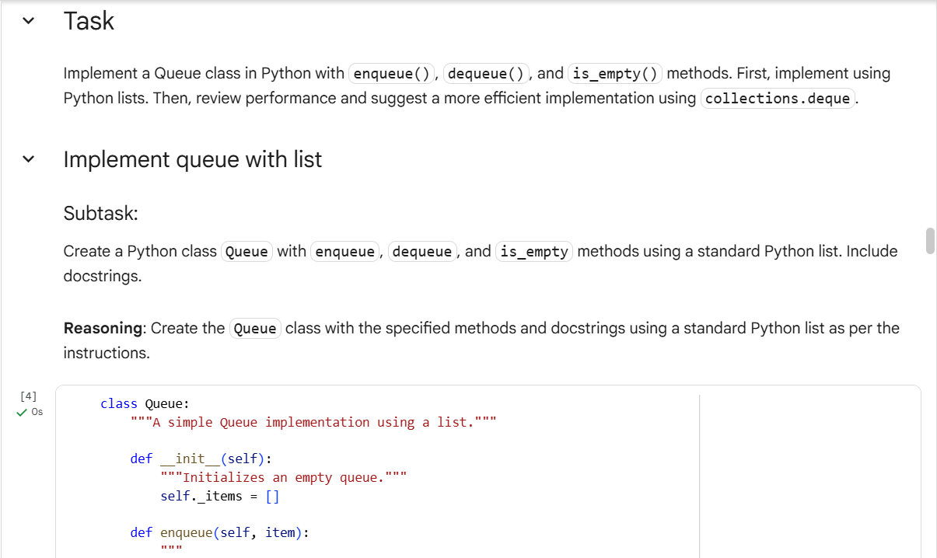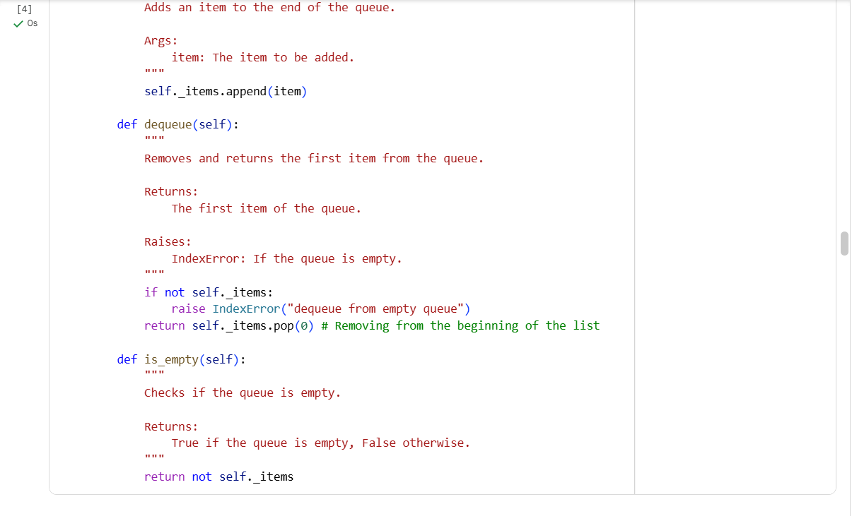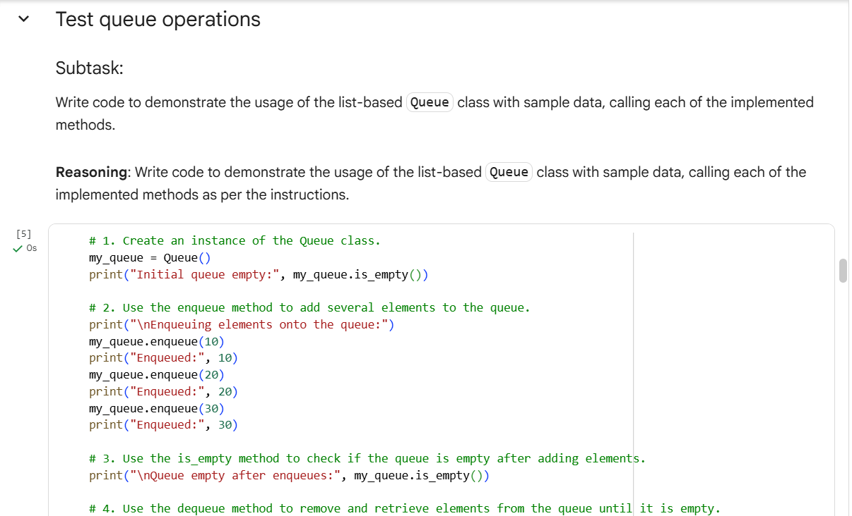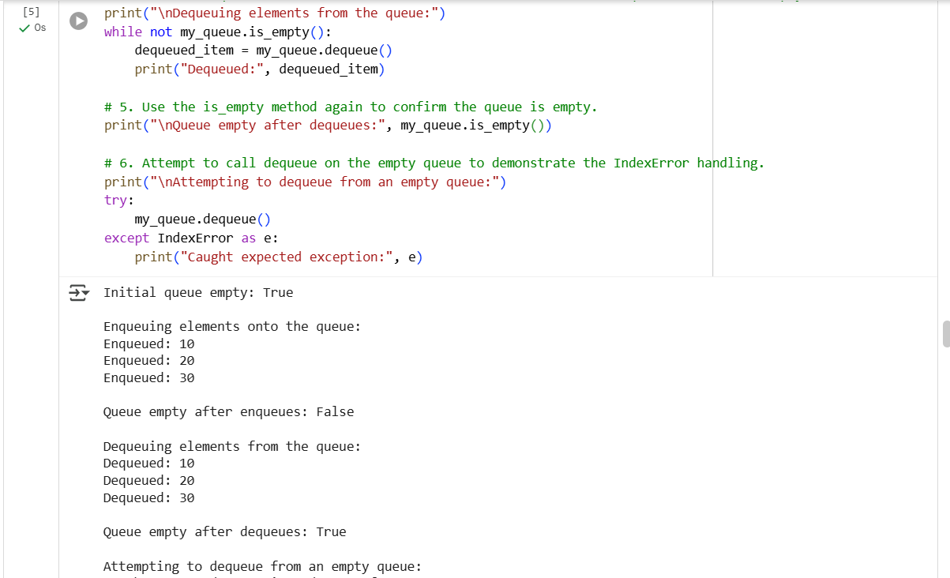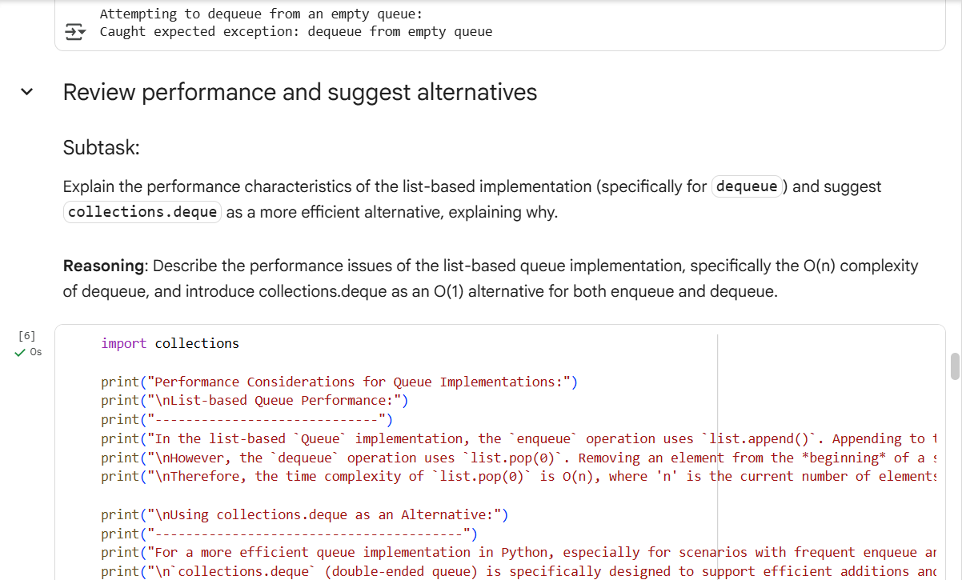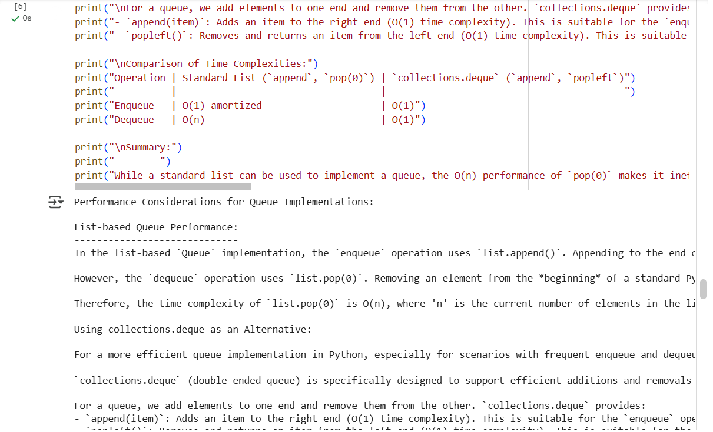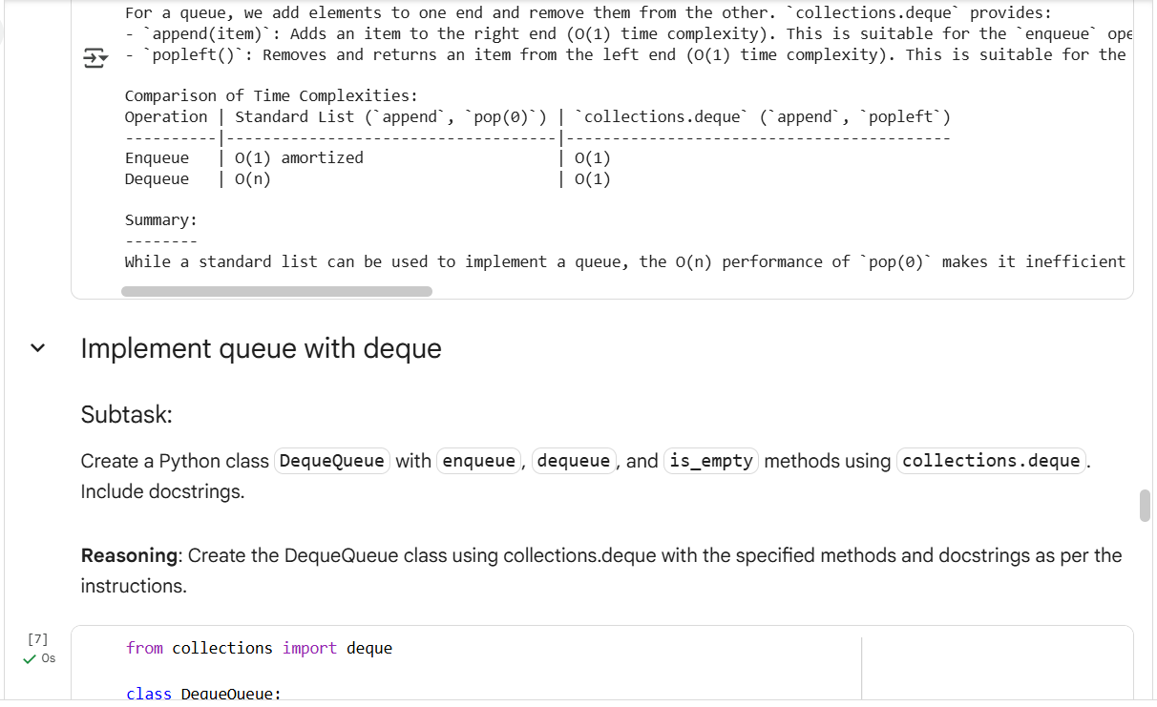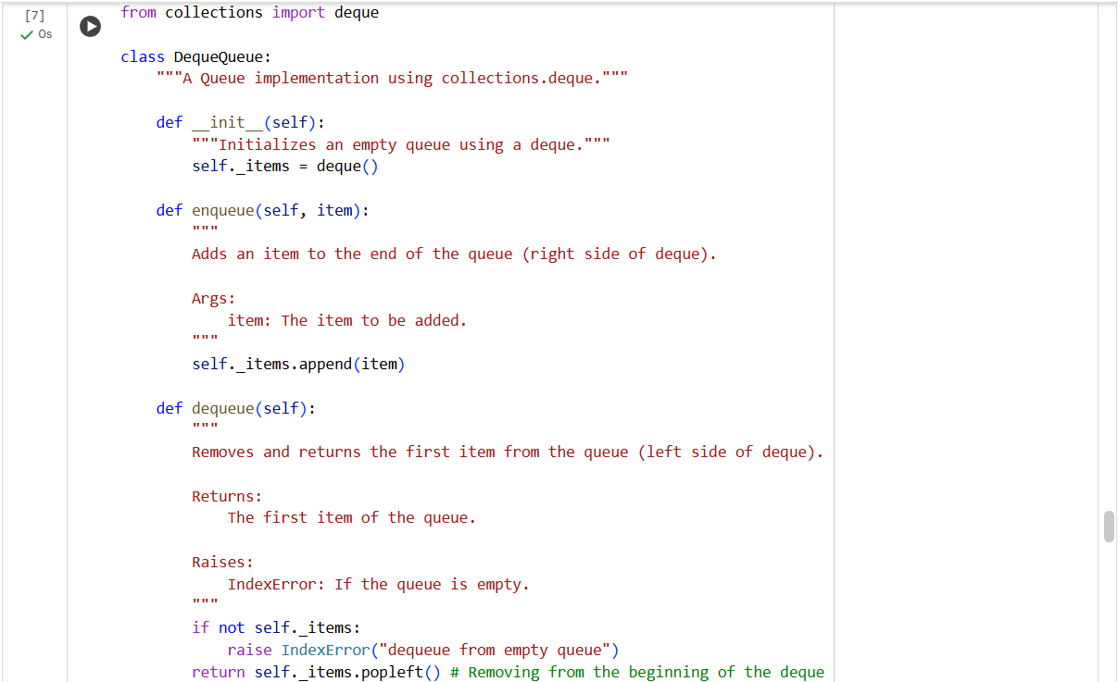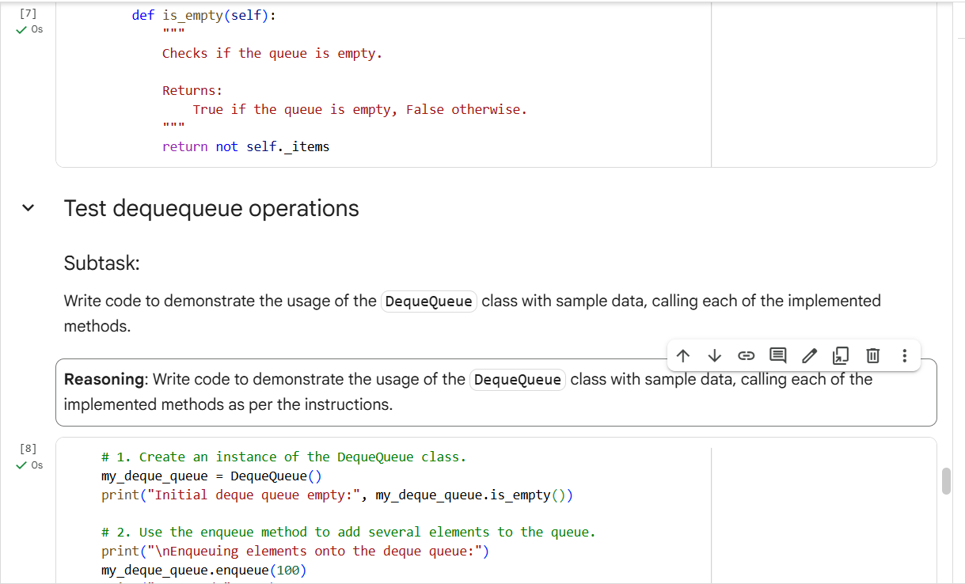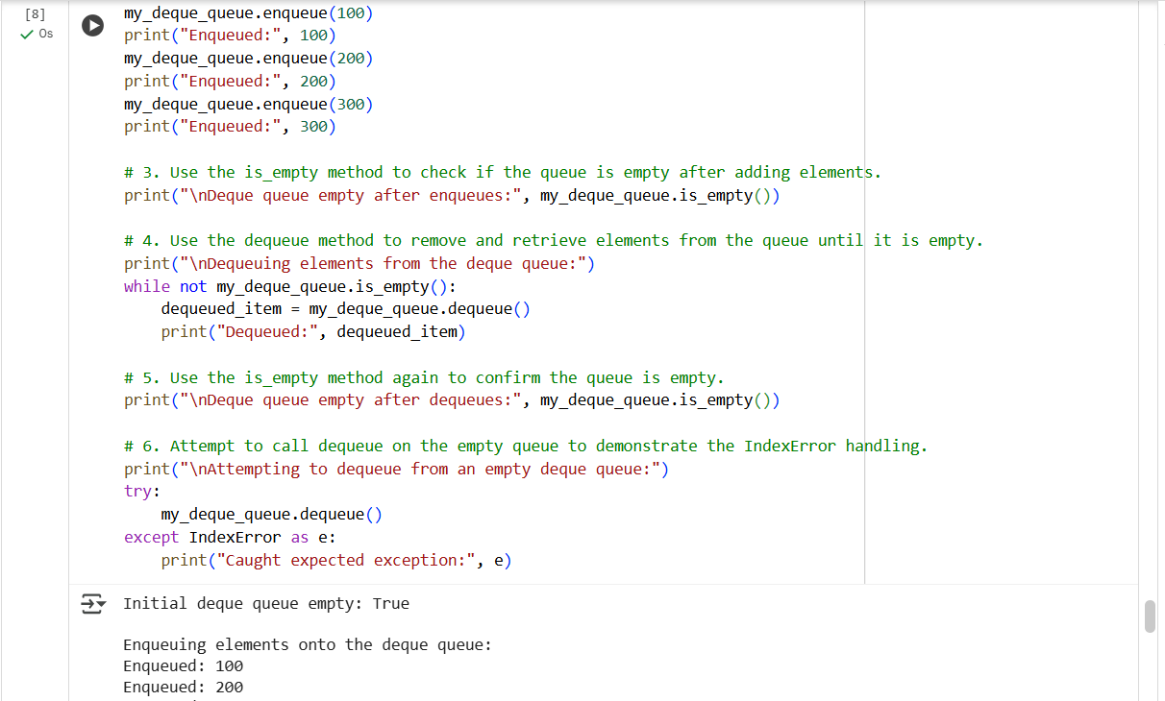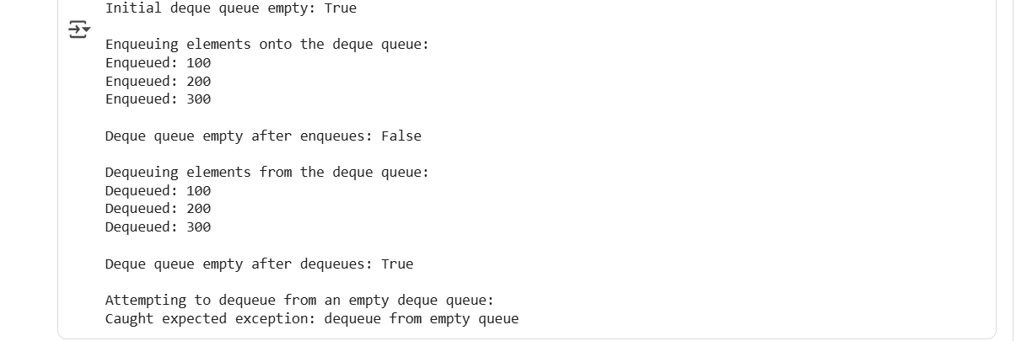
Explanation:
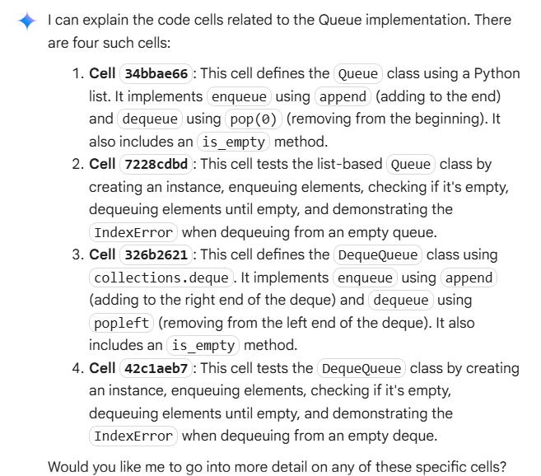

Task 3: Singly Linked List with Traversal
• Task: Implement a Singly Linked List with operations:
insert_at_end(), delete_value(), and traverse().
• Instructions:
o Start with a simple class-based implementation (Node,
LinkedList).
o Use AI to generate inline comments explaining pointer updates
(which are non-trivial).
o Ask AI to suggest test cases to validate all operations.
• Expected Output:
o A functional linked list implementation with clear comments
explaining the logic of insertions and deletions.
Code:
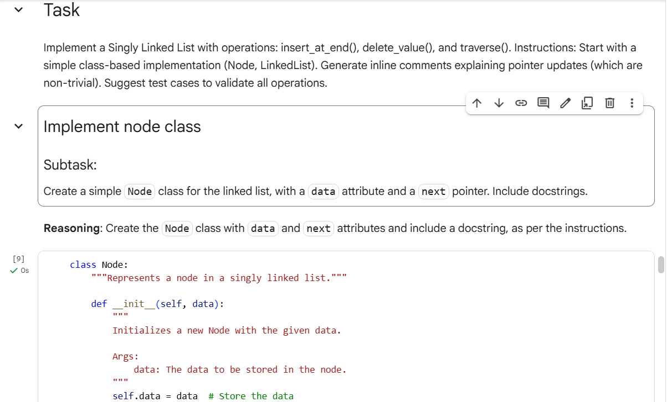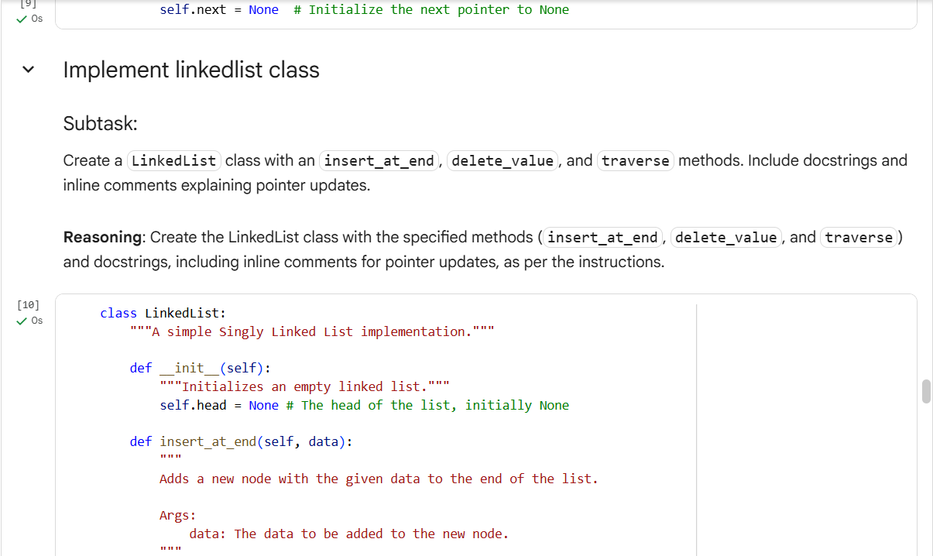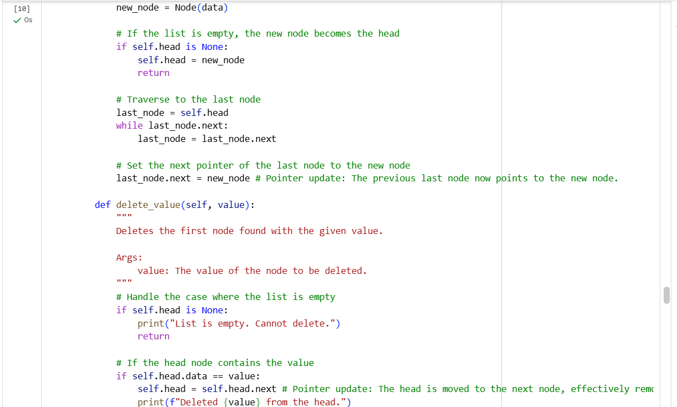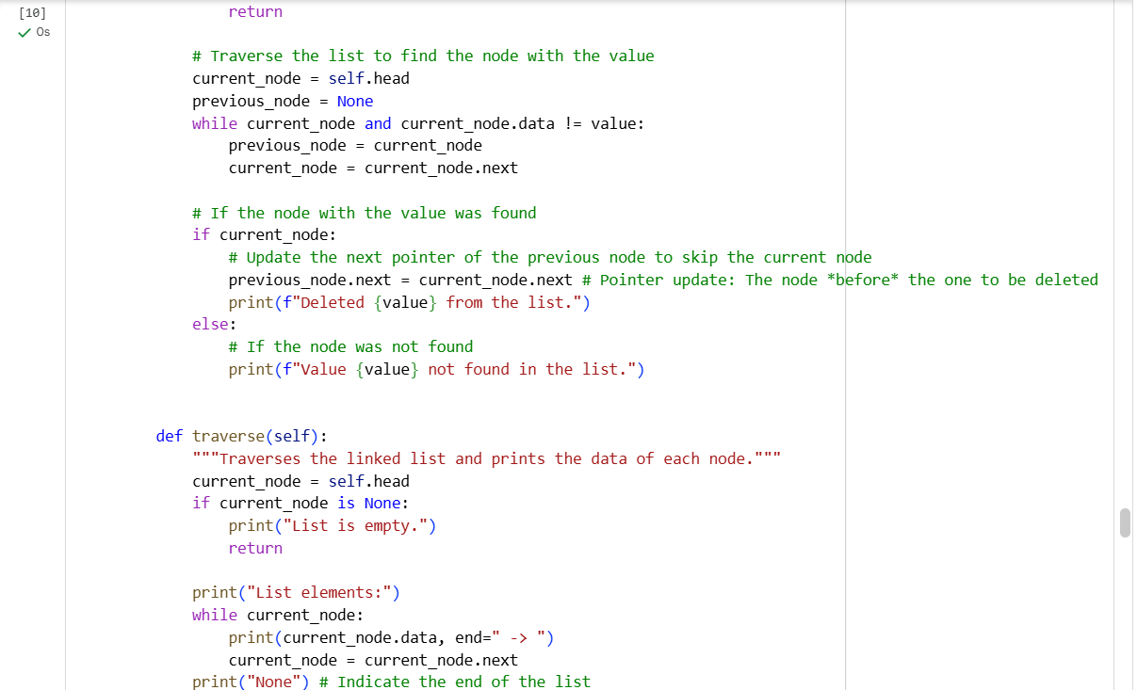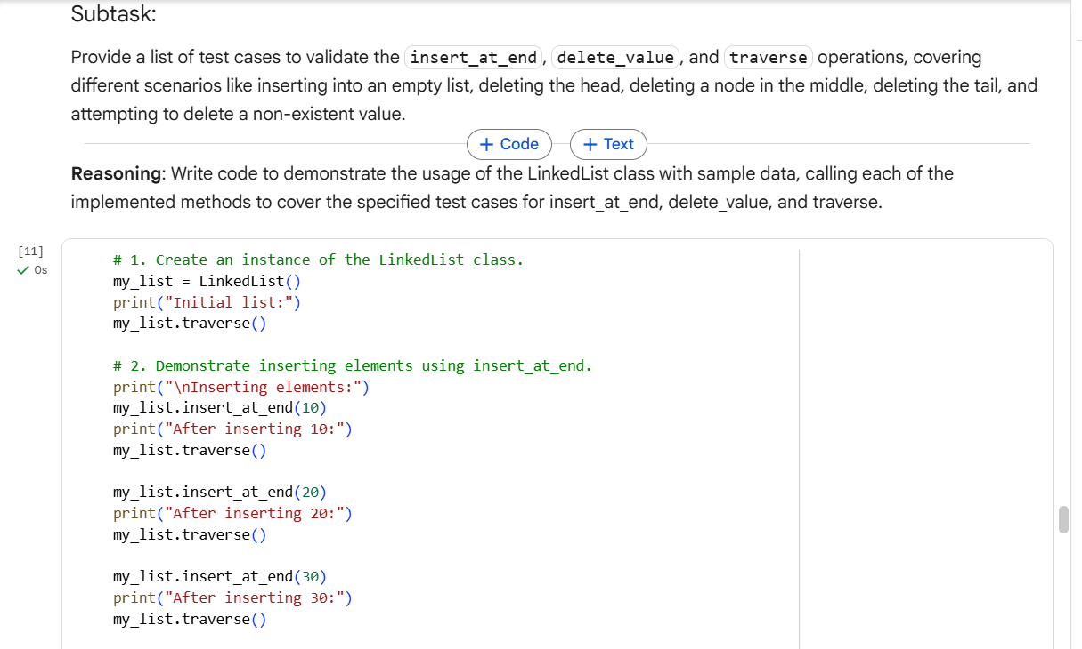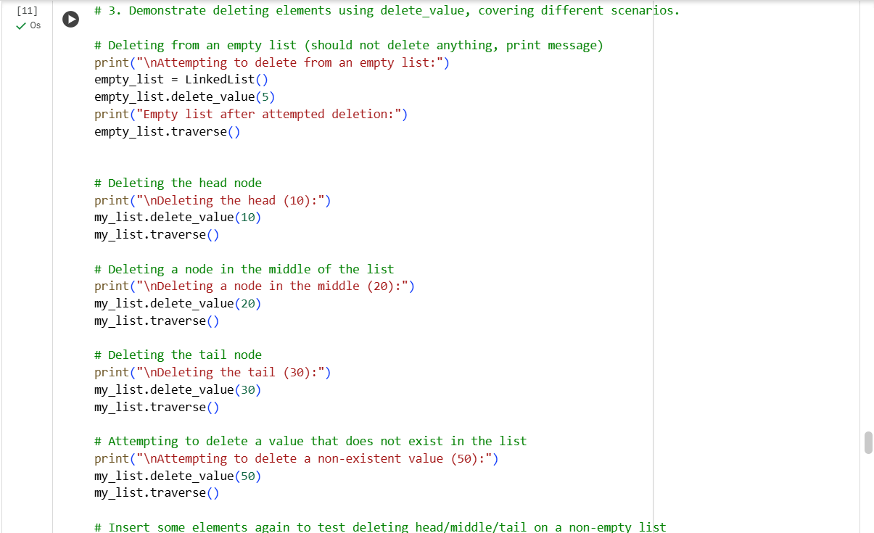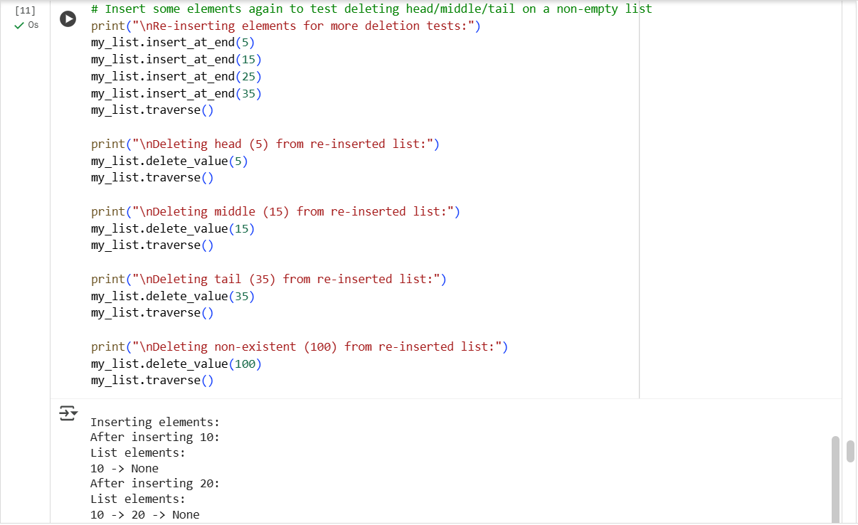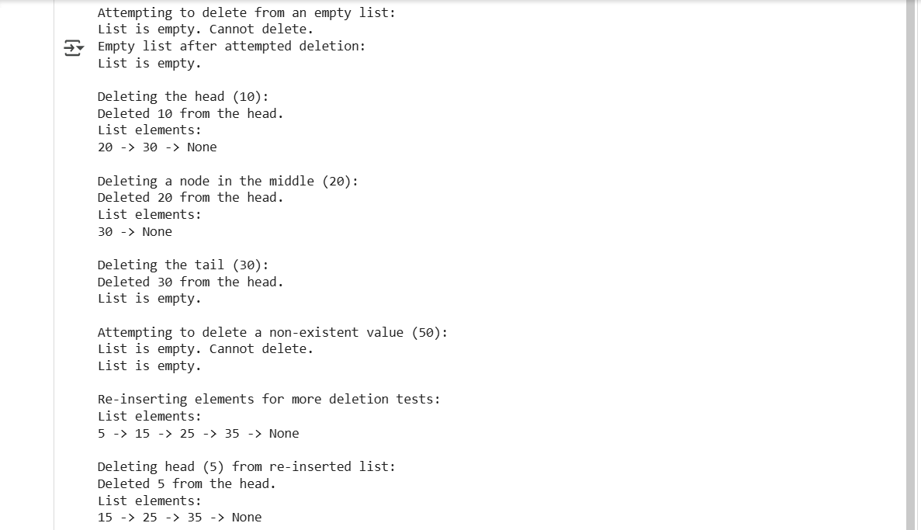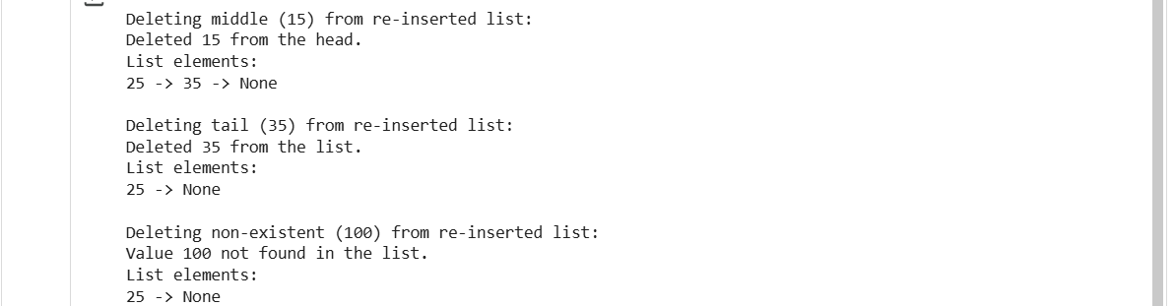

Explanation:
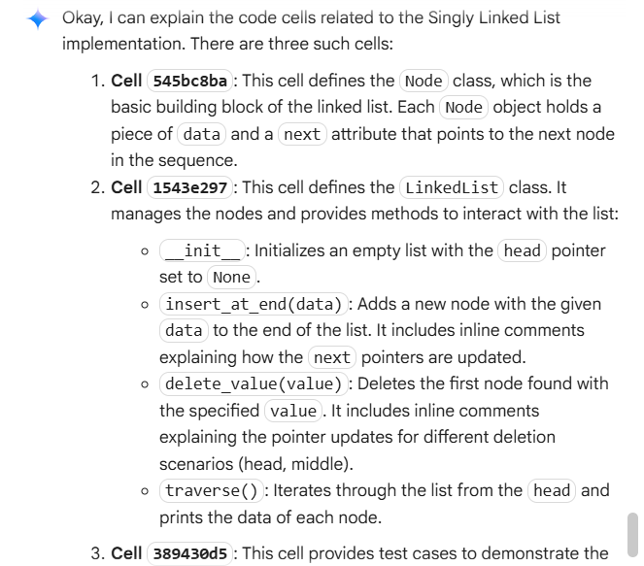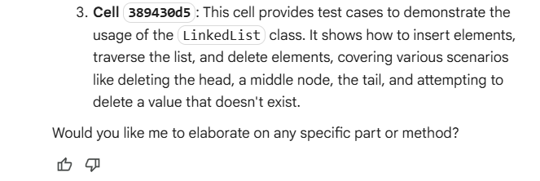

Task 4: Binary Search Tree (BST)
• Task: Implement a Binary Search Tree with methods for insert(),
search(), and inorder_traversal().
• Instructions:
o Provide AI with a partially written Node and BST class.
o Ask AI to complete missing methods and add docstrings.
o Test with a list of integers and compare outputs of search() for
present vs absent elements.
• Expected Output:
o A BST class with clean implementation, meaningful docstrings,
and correct traversal output.
Code:
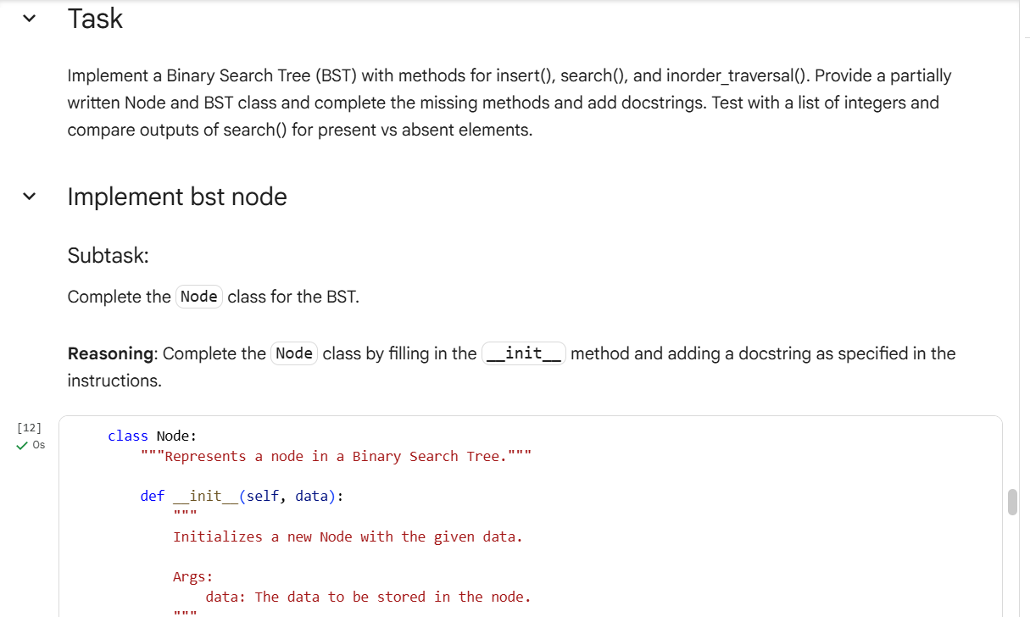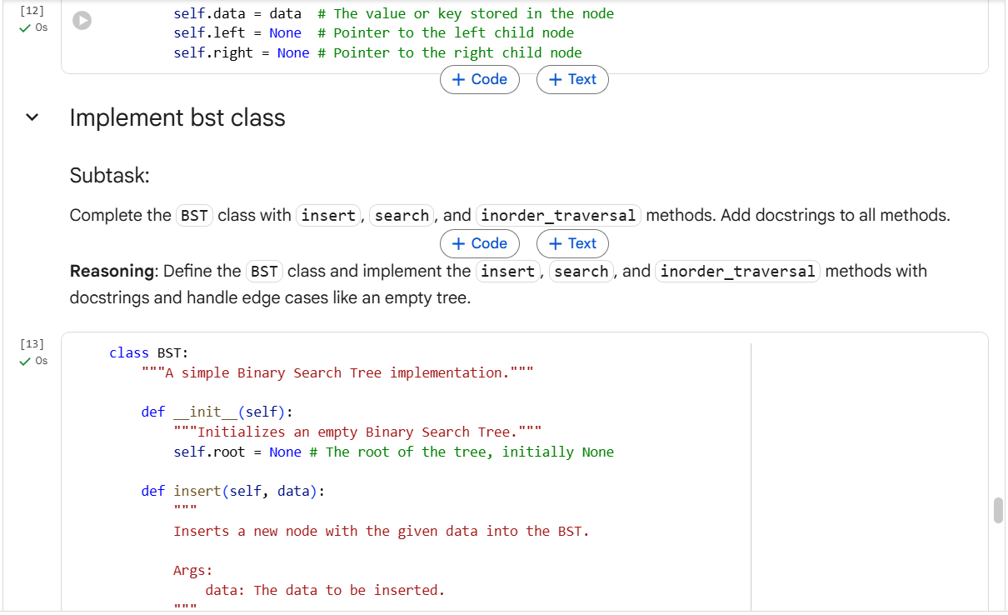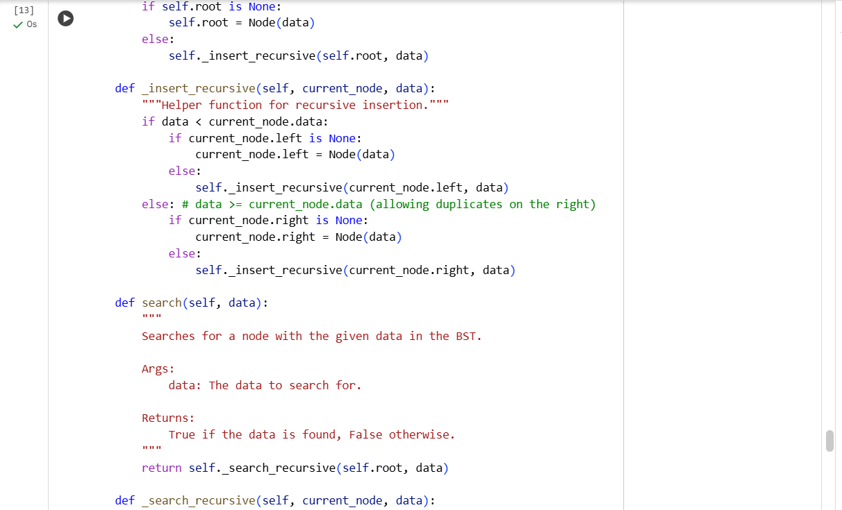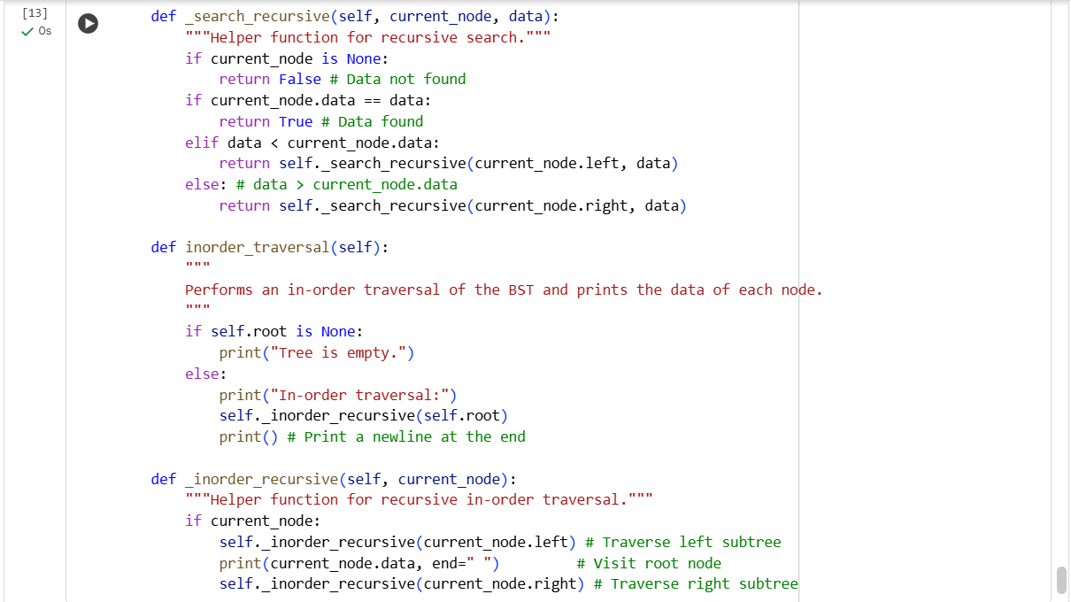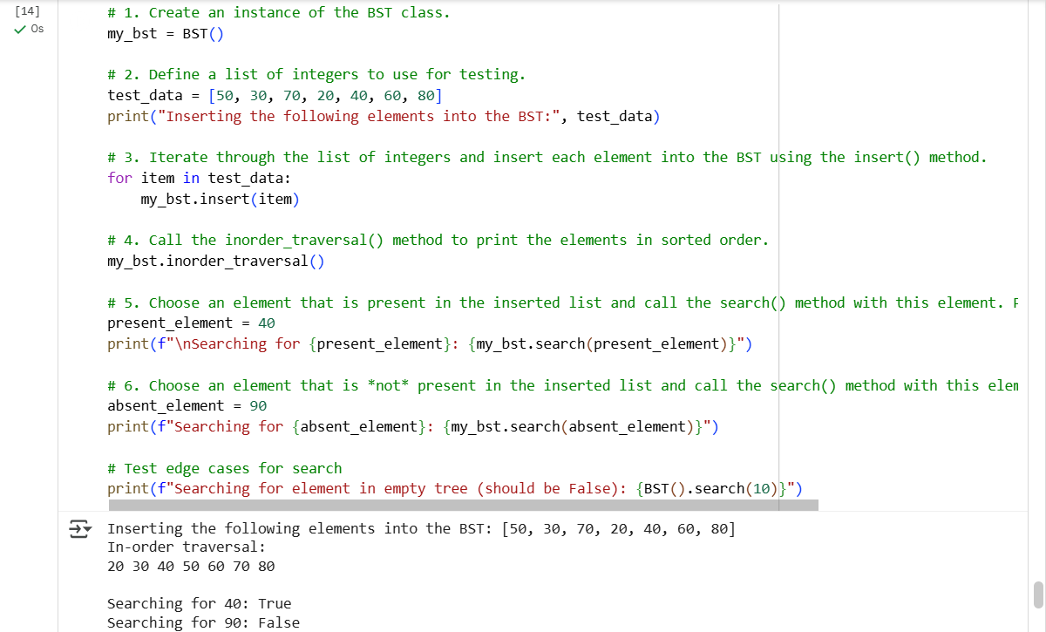
Explanation:
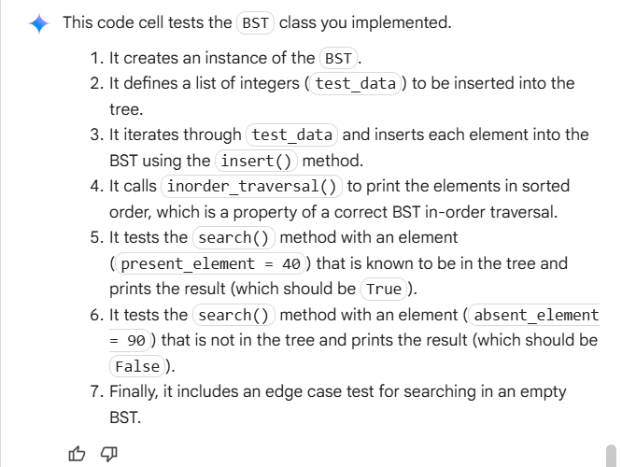

Task 5: Graph Representation and BFS/DFS Traversal
• Task: Implement a Graph using an adjacency list, with traversal
methods BFS() and DFS().
• Instructions:
o Start with an adjacency list dictionary.
o Ask AI to generate BFS and DFS implementations with inline
comments.
o Compare recursive vs iterative DFS if suggested by AI.
• Expected Output:
o A graph implementation with BFS and DFS traversal methods,
with AI-generated comments explaining traversal steps.
Code:
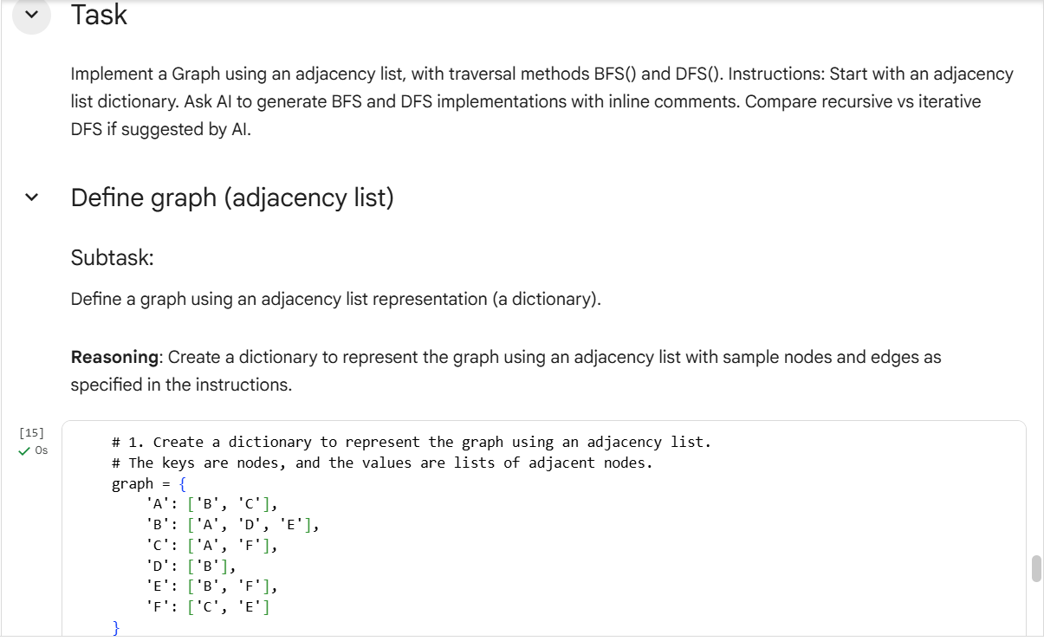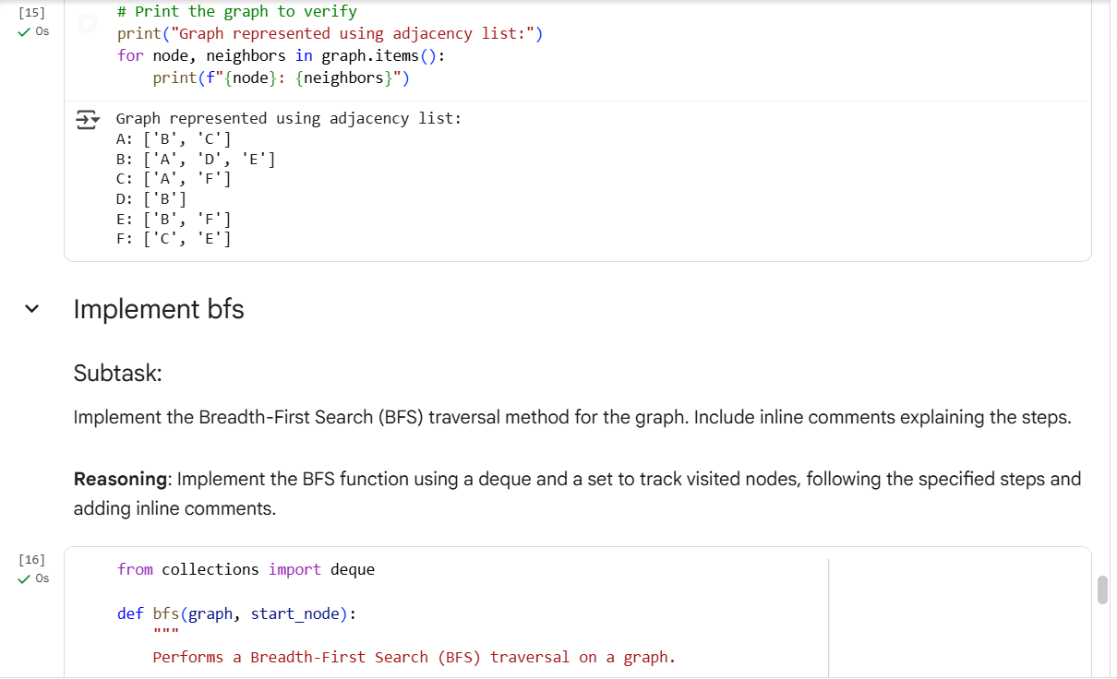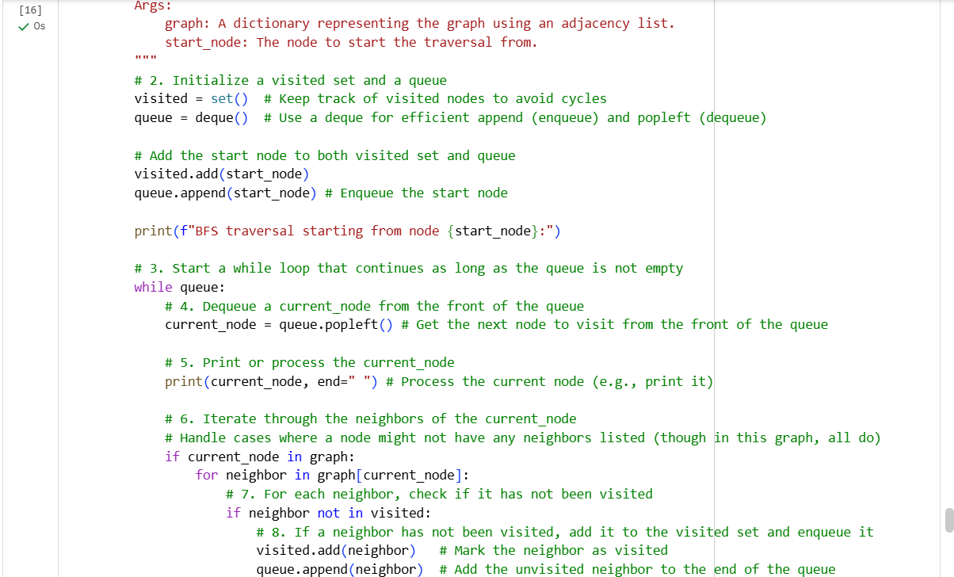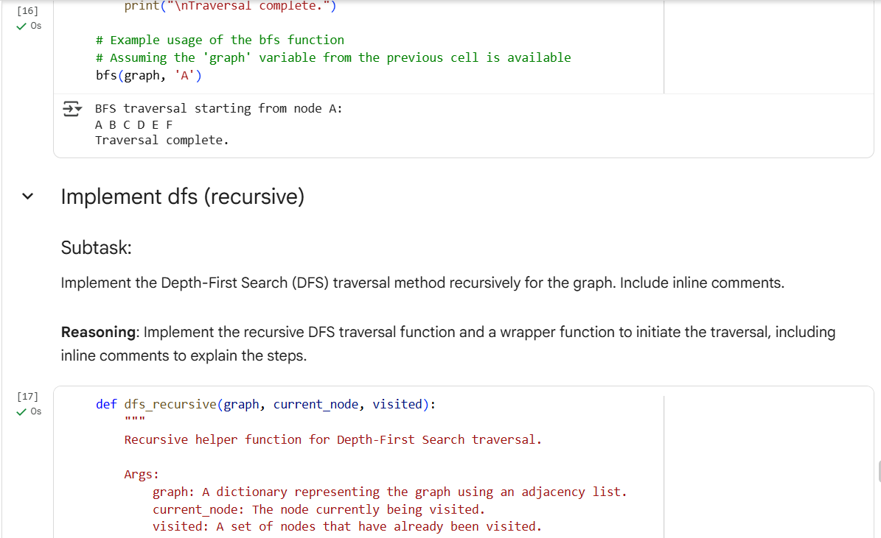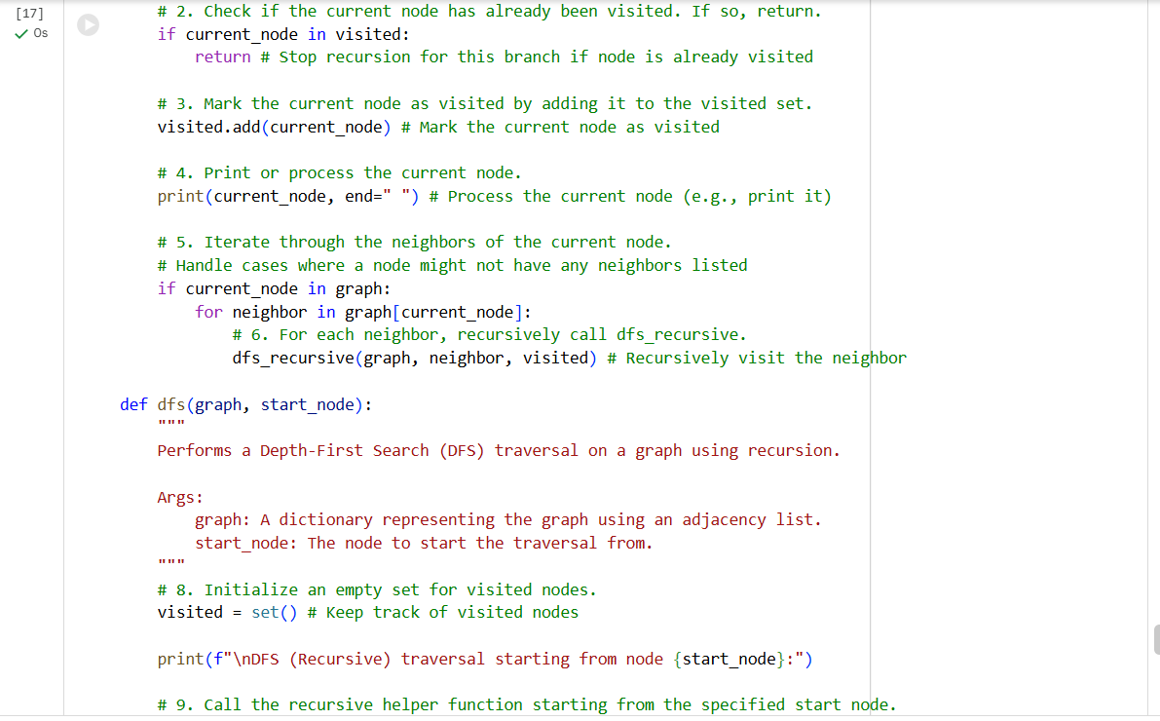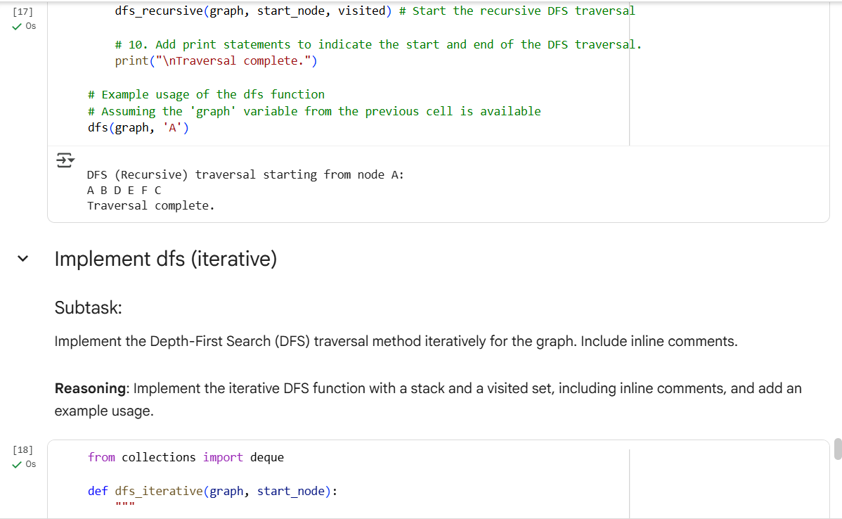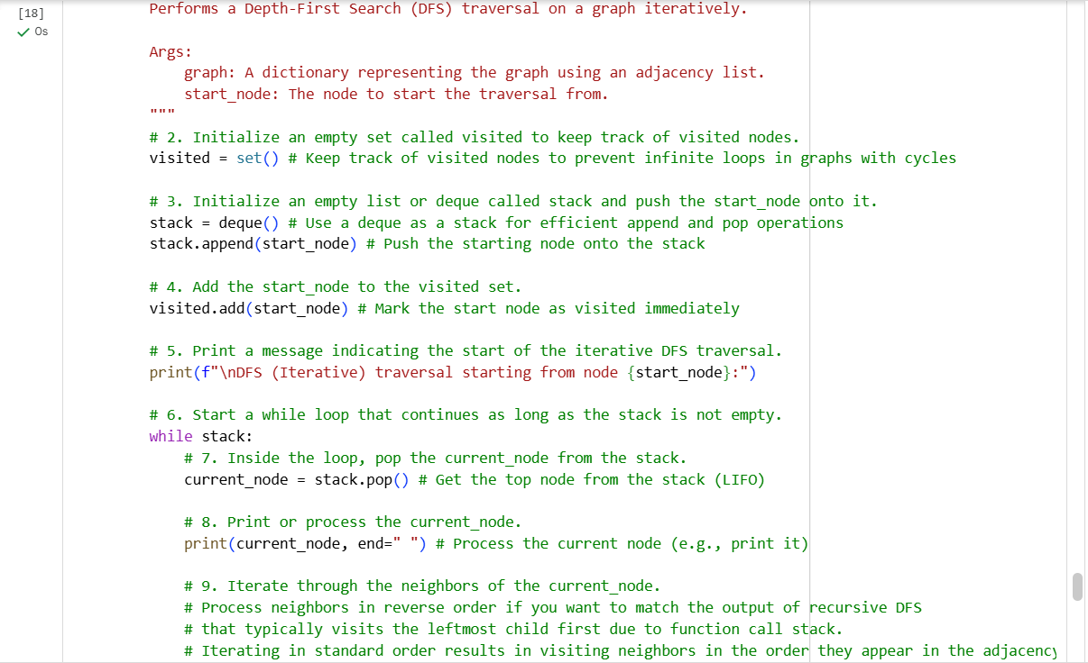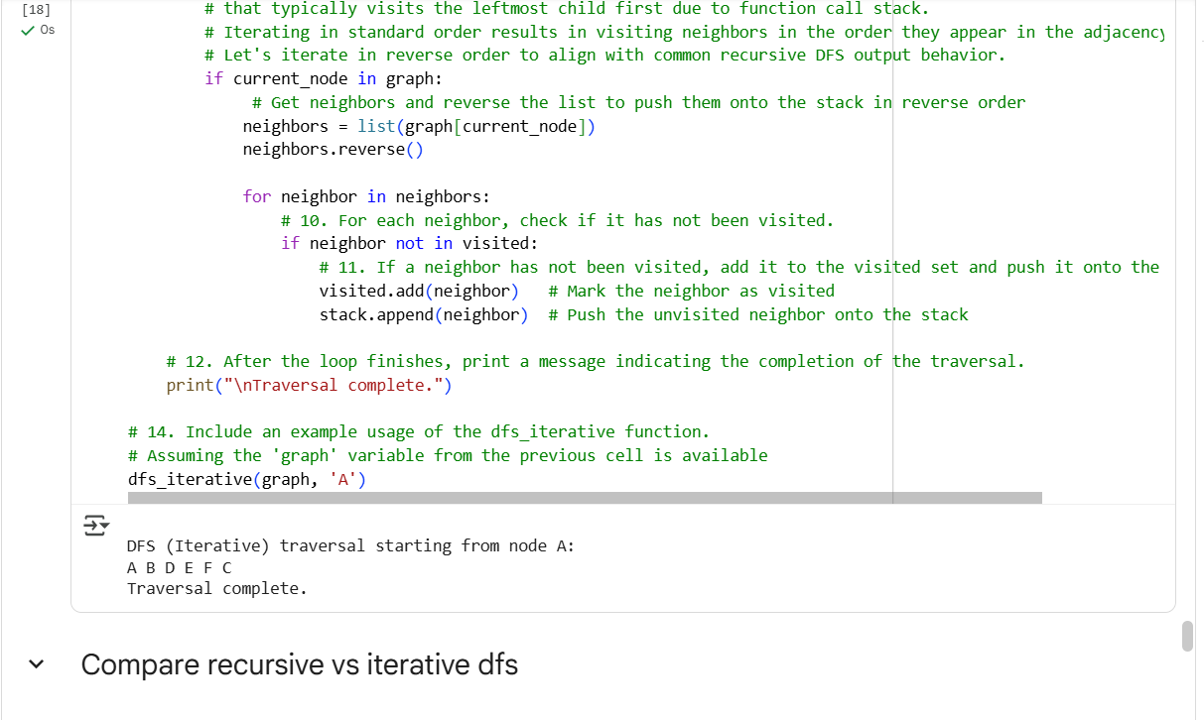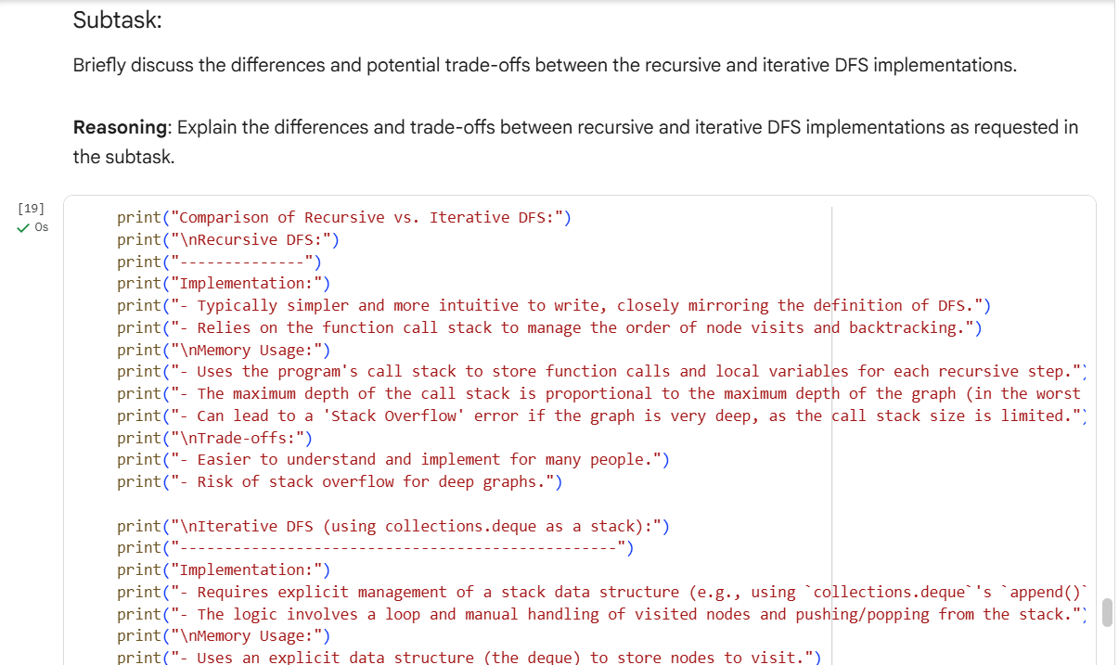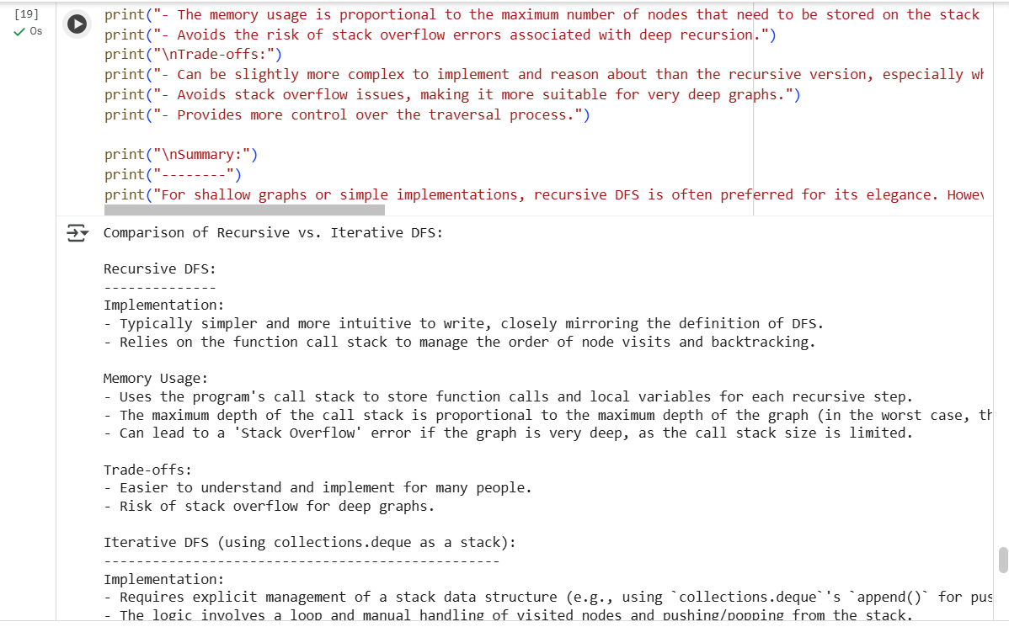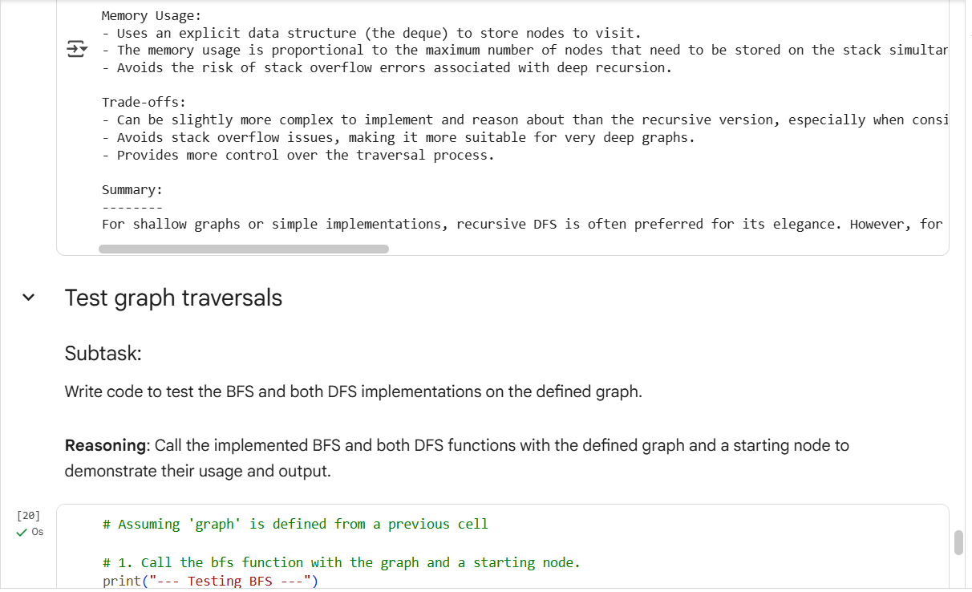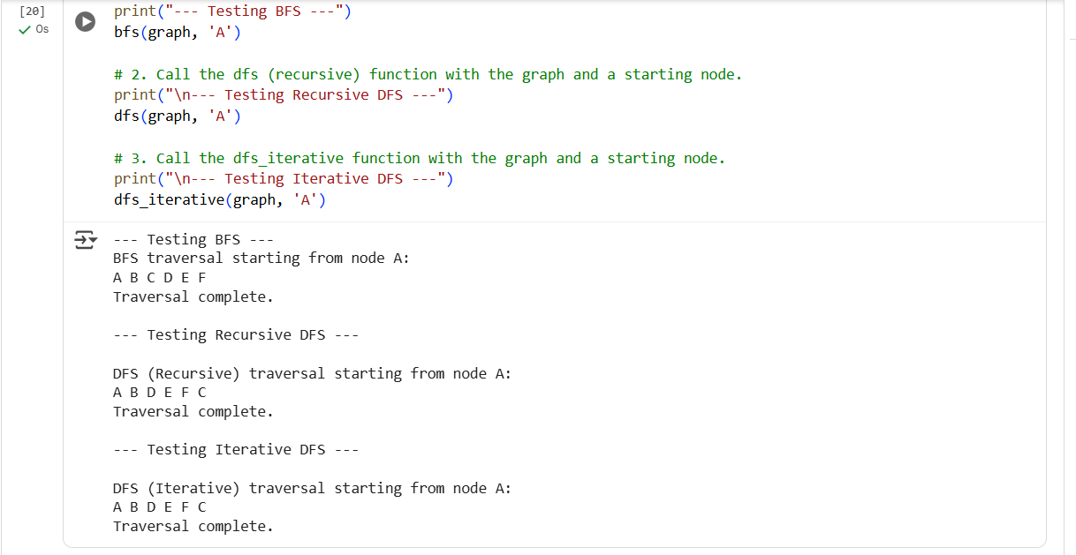
Explanation:
